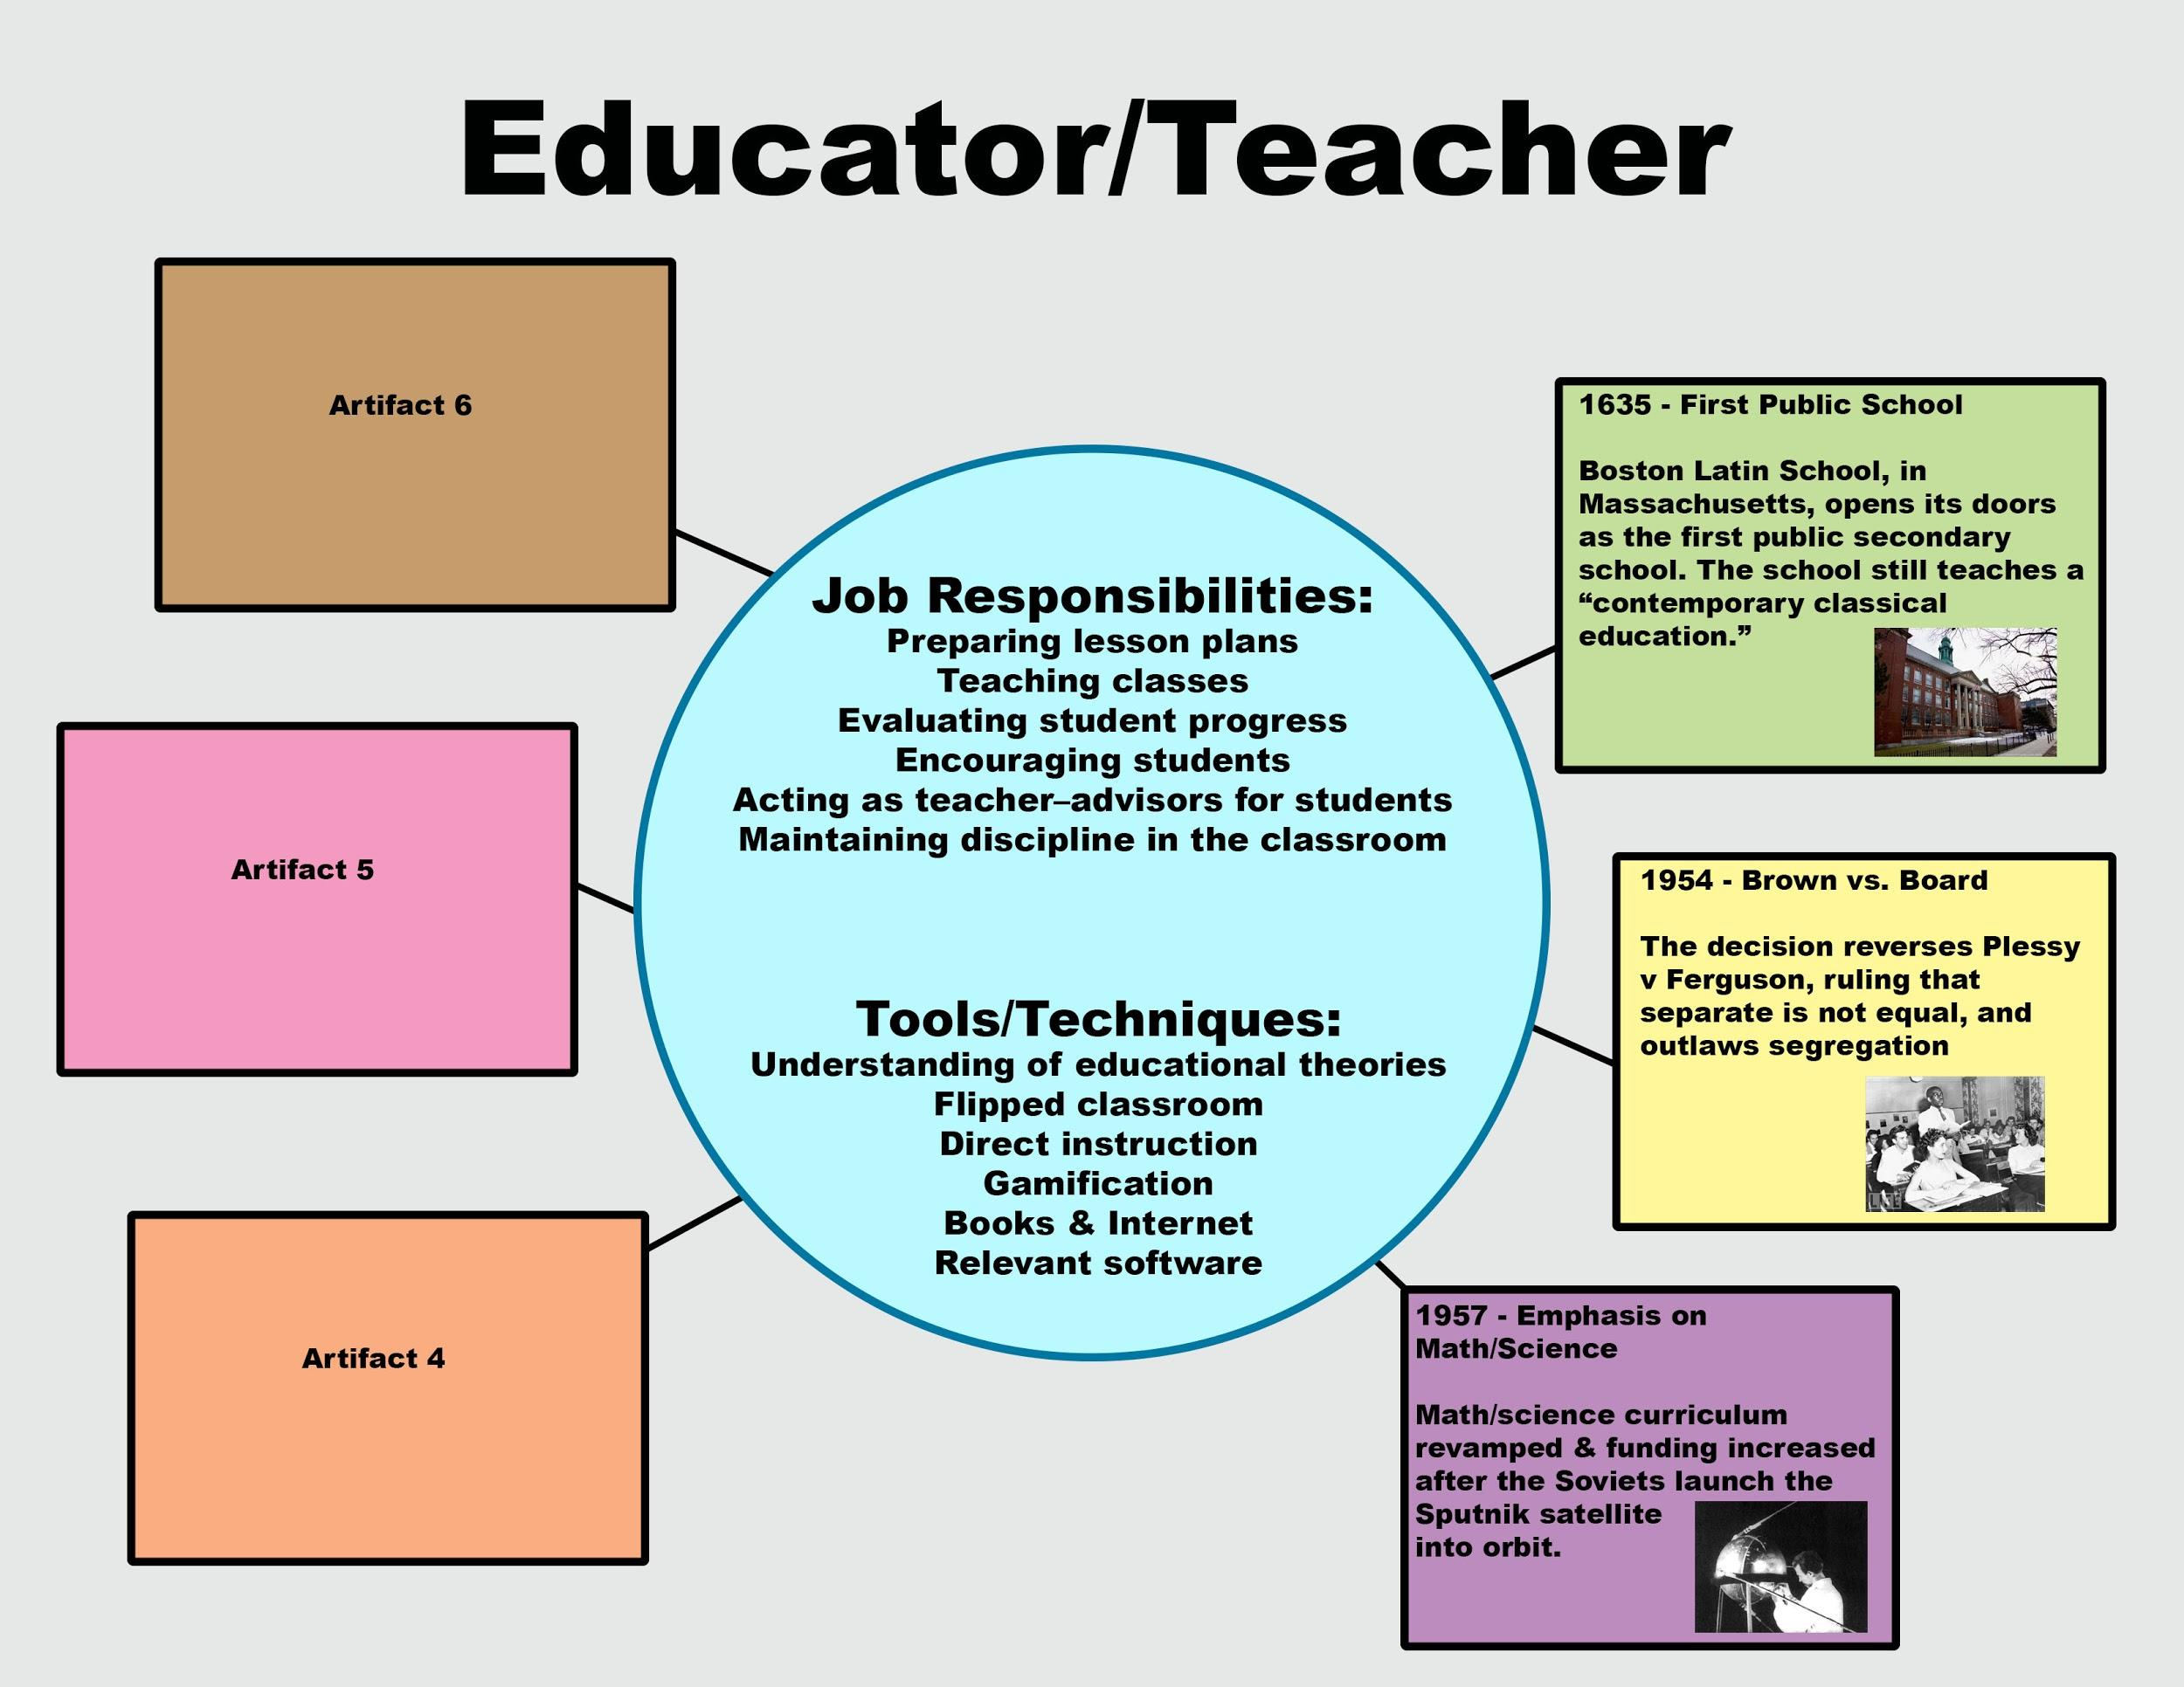
1.01 Career Development Timeline
Instructions: Select one of the careers that interests you from the options listed below. For this activity, you are going to research major advancements and historical events that led to the development of that career from its inception to current day. You will then use this information to create a timeline that illustrates the key moments in the development of the field selected.

Careers:
- Graphic Design  - User Interface (UI) Design  - Character Artist (Game)  - Environment Artist (Game) | - Texture Artist (Game)  - Multimedia Artist & Animator  - 3D Modeler  - Web Design/Development | - Photographer  - Sound Designer  - Film & Video Editor

Product Requirements:
Create your timeline in PowerPoint, Google Slides, Prezi, Chronozoom, using original graphics, etc.

- Research your selected career
- Somewhere in your timeline, you will need to include:
  - a description of the career you selected including the job duties/responsibilities and important tools/techniques used by employees.
- Find a minimum of 10 important developments or historical events that relate to how that career has advanced over time. These will form your artifacts. Do not limit yourself to only digital advancements. If there are important advancements before the digital revolution, include them when possible!
  - Each artifact needs to include: a title, the date it took place, a relevant graphic, and an explanation of why it is important for your selected career.

